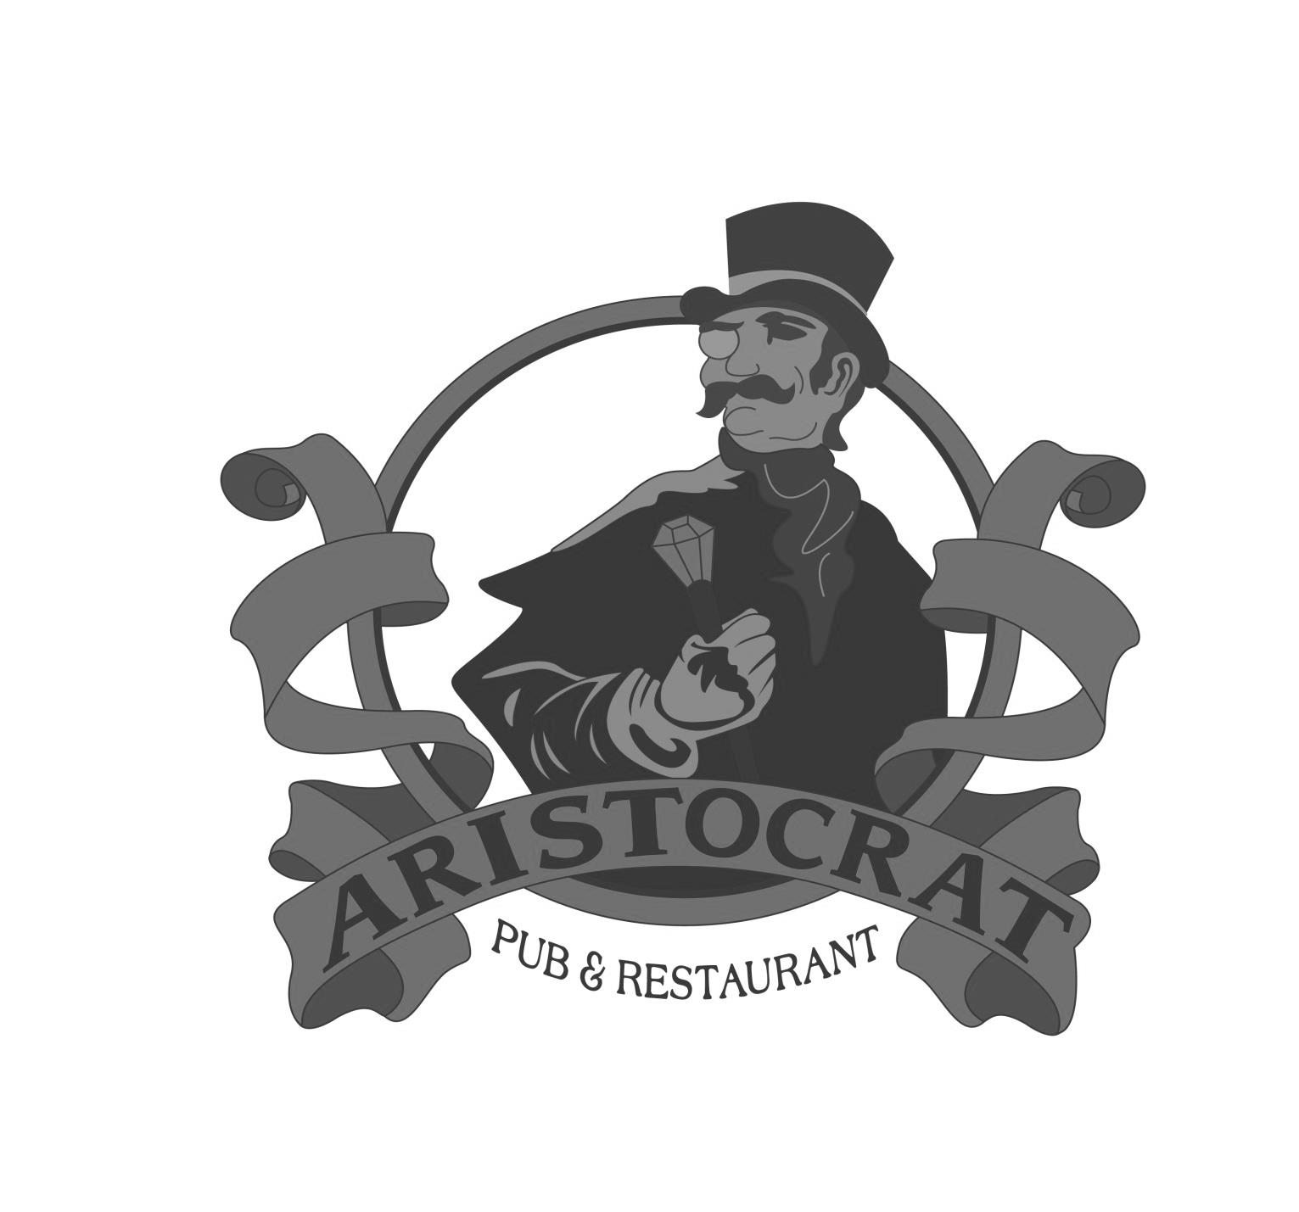
BRUNCH
ON THE AVENUE

Established 1933

BRUNCH ON THE AVENUE SUNDAY 11-2
Established 1933
BLOODY MARY’S $9
Choose your rim: Cajun or Seasoning Salt
Choose your mixer: Original or Clamato
Choose your Vodka: Three Olives, Three Olives Cucumber Lime, Absolut, Absolut Cilantro, Absolut Pepper, Absolut Citron, Stolichnaya, Tito’s, Fuzzy’s, Grey Goose, or
Ketel One
MIMOSA MADNESS $6
Classic Mimosas featuring Kenwood Yulupa Brut,
Choose: Peach, Strawberry, Mango or Orange
FRITTATAS
Served with your choice of potato casserole, steak fries,
or fresh fruit and an English muffin or toast
The Italian~ Zucchini, artichokes, tomatoes, black olives, feta, and provolone $10
The Western~ Ham, onion, green pepper and cheddar cheese $10
The West Coast~ Applewood smoked bacon, tomato, spinach and mozzarella $10
The Veggie~ Mushrooms, green & red peppers, onions, spinach and mozzarella $10
SPECIALTIES
Steak and Eggs~ 6 oz. Bourbon Marinated Flat Iron with eggs to order and steak fries $16
Huevos Rancheros~ Corn tortillas topped with spicy black bean salsa, melted mozzarella and cheddar cheeses, two poached eggs, tomatoes, jalapenos and red onions. Sour cream and salsa on the side $10
Yogurt and Granola~ Yogurt layered with granola and fresh strawberries, bananas and blueberries $8
Chicken and Waffle~ Waffle served with our hand breaded chicken fingers and a side of potatoes $11
WAFFLES, PANCAKES AND FRENCH TOASTS
Belgian Waffle~ House waffle topped with strawberries, blueberries, bananas and dusted with powdered sugar $7.50
Chocolate Chip Waffle~ House waffle with chocolate chips topped with fresh strawberries and powdered sugar $7.50
New Orleans French Toast~ Thick cut bread prepared with Grand Marnier batter and dusted with powdered sugar $8
Buttermilk Pancakes~ Three fluffy pancakes with warm maple syrup $6
Blueberry Pancakes~ Three buttermilk blueberry stuffed pancakes with warm maple syrup $7
Chocolate Pancakes~ Three buttermilk chocolate chip stuffed pancakes with warm maple syrup $7
THE BENEDICTS
Served with your choice of potato casserole, steak fries or fruit.
The Original ~ Two poached eggs, Canadian bacon and English muffin served with Hollandaise sauce $9.50
Crab Cake~ Our house crab cake over an English muffin topped with a poached egg and served with Hollandaise sauce $10.50
Eggs Florentine~ Two poached eggs, fresh spinach and cream cheese over an English muffin topped with Hollandaise sauce $9.50

ALA CARTE
Toast or English Muffin $1.50
Potato Casserole $2.25 Steak Fries $2.25 Applewood Smoked Bacon $3
One Egg $1.50 One Pancake $2 Fresh Fruit $2.25

SANDWICHES
All of these Sandwiches are served with your choice of either House Cole Slaw or Kettle Chips or you may upgrade to one of our delicious side dishes…
French Fries, Onion Rings, Fresh Vegetables or Potato Salad $2.35

The Hoosier Tenderloin
Ours is center cut from fresh pork loin, coated with seasoned breading and fried golden. You can have it grilled if you prefer $13

Chicken Breast Sandwich
We can simply grill it or season it Cajun or lemon-pepper style, served on a toasted bun $10.50

Classic Club
Ham, smoked turkey, Swiss and American cheese, Applewood smoked bacon, lettuce and tomato stacked up with mayo and your choice of toasted bread $12

Applewood Smoked Bacon, Lettuce &Tomato
A triple decker of crisp Applewood smoked bacon, tomato slices, lettuce and mayo on your choice of white, wheat or rye toast $10
Choose California Style: Slices of avocado and pesto mayo add $1.50

Cherry Chicken Salad
Chunks of chicken breast blended with tart Michigan cherries and crunchy walnuts inside a croissant $11.50

Chicken Gator Roll
Grilled Cajun chicken, Cheddar, black bean dip, lettuce, and tomato in a wrap with a side of BBQ sauce $11.50

SALADS
7 0z. Bourbon Flat Iron Salad
Marinated and grilled over mixed greens, avocados, red onion, tomatoes and balsamic vinaigrette $16

Strawberry Blues
Romaine, strawberries, cantaloupe, Gorgonzola, green onions, sugared, toasted walnuts, creamy raspberry vinaigrette $10
(add Chicken $3.70, Shrimp $5.00 or Breaded Chicken Tenders $5.00)

Cobb Salad
Greens, bacon, egg, avocado, tomato, alfalfa sprouts and Gorgonzola crumbles $10 Choose your dressing!
(add Chicken $3.70, Shrimp $5.00 or Breaded Chicken Tenders $5.00)

